**Montclair State University**

2017

**TreeLOG**

**Tree Map Mobil Application**

**PUMA**

Contents

[1. Description of the problem and social impact (draft) 3](#_Toc480589181)

[2. Credits (draft) 5](#_Toc480589182)

[3. Target Users and audience (draft) 5](#_Toc480589183)

[4. Competitive solutions and the deficiencies of those solutions (draft) 6](#_Toc480589184)

[5. Solution for the TreeLOG application 13](#_Toc480589185)

[6. TODO: Describe the feedback that you got on your initial working prototype: how many participants you had and their demographic characteristics (but don’t include personally identifying information). Summarize the problems you discovered and describe what you changed in your final prototype to address those problems. Feedback 16](#_Toc480589186)

[7. Open issues 16](#_Toc480589187)

[8. Future of the project 17](#_Toc480589188)

[9. Achievement in CfC 2017 (draft) 18](#_Toc480589189)

[10. References (draft) 19](#_Toc480589190)

1. Description of the problem and social impact (draft)

The initial idea of the TreeLOG project came up as a desire to participate in the competition for techies, as well as a need to find a topic for a group project for the Mobile Computing class. We started to work with Sustainable Camden County and participate in Sustainable New Jersey Competition (CfC 2017). The objective of this competition is the opportunity to work with a NJ town to collaboratively build a sustainable solution to a challenging local problem, and make a real impact on real issues. Every participant or a group of participants had to choose a project from the list available on the website of the [CfC 2017](http://cfc.sustainablejersey.com/). Our team PUMA made a decision to create a mobile application to help mapping trees in all 21 neighborhoods of Camden City. We chose the name TreeLOG for this future mobile application.

Trees are essential to life, providing significant aesthetic, environmental, and ecological benefits. Yet trees can fall or shed branches, potentially injuring property or even people. If you have trees in a landscape, or simply walk or work in public spaces with trees, it’s important to be on the lookout for potential hazards. Currently, volunteers of the Camden City, carry physical paper spreadsheets to catalogue a street tree's location, health, general size, type, potential hazards, etc. Some of that info is then manually inputted to a spreadsheet that is then converted and uploaded to a Google Map. In order to improve the quality of the City's street tree inventory, a more efficient way to survey and get baseline data on street trees would better manage risk, the health and growth of its canopy. Crowd sourcing capabilities are also needed.

The main purpose was to have the inventory of the trees is for getting grants that the city can use to replant certain areas and neighborhoods. The city should have a coverage of 20% with trees, but currently only have 8-9% coverage.

Conducted studies in the development process have shown that tree inventory involves more use than helping one community and includes several different goals and directions. There are four main types of tree inventory.[1] They are specific problem inventory, partial inventory, complete inventory, and cover type inventory. A specific problem inventory gathers data on one particular problem such as looking at the effects of some diseases. A partial inventory uses sampling where only a subset of the trees in the community are observed to draw inferences on the whole forest. A complete inventory collects data from all trees in the population, and a cover type survey is a survey where some of the information gathered is usually done through aerial photography and GIS systems.

According to the types of inventory listed above and the task set by the municipality of Camden, the program TreeLOG is classified as a complete inventory.

A tree inventory may be conducted for many reasons, such as to determine if a community needs to implement an urban forestry program[2], in order to prioritize tree maintenance needs, to plan for the community's future, and to provide a basis for the implementation of a management plan.

1. Credits (draft)

|  |  |
| --- | --- |
| Position/Title  (Alphabetical order of the team members by First name) | First Name and Last Name  (Equal contribution) |
| Moaath Alrajab | Instructor |
| **Members of the PUMA team** | |
| Eliezer Epstein | Classes and methods to work with Google Map and coordinates, related UI |
| Elion Limanaj | DB DAO's, user Auth, Auth related UI, location detection |
| Inga Gaidukova | UI, classes and methods for UI to DB integration |
| Supriya Karambe | Classes and methods to work with Photos, related UI |
| Zahid Aziz | DB DAO's, user Auth, Auth related UI |

1. Target Users and audience (draft)

These inventories are generally conducted by student groups and volunteers, or contracted to urban forestry consultants, or by municipal urban foresters using either handwritten methods, software, templates, Smartphones or PDAs.

It was assumed that for the initial idea of the project, volunteers from Sustainable Camden County Municipality, who are mapping trees, were to be future users of the application. In light of the studies conducted, users of this application may not only be volunteers from Camden County Municipality, but also any organization that maintains an inventory of parks, city streets etc, such as, for example, New York City Department of Parks & Recreation which maintains all parks in Great NYC area. (more audience?)

The Application was created for the devices with Android platform.

1. Competitive solutions and the deficiencies of those solutions (draft)

Initial data for searching competitive applications:

* Keywords: tree inventory, tree inventory app, tree hazard
* Rating: all ratings
* Price: paid and free (listed below free applications were installed for testing, paid were evaluated from the point of view of the presented accompanied promotional description )
* Promotion: Pay-Per-Click campaign (PPC, means that application was found in paid section and has financial support for distribution) or General catalog
* **Competitive applications which could be found in AppStore**

|  |  |
| --- | --- |
| Application screen | Description |
| TreeIDUSA.jpg | * Name: Tree ID USA * Rating: 4 of 5 * Price: $4.99 * Promotion: PPC campaign |
| **Pros:**   * Nice design, allows to build own plots with trees and bushes * Well supported * Tree recognition implemented by using step by step instructions |
| **Cons:**   * Paid * Mostly concentrated on tree recognition than on inventory * Build for iOS only |
| ArborPlus.jpg | * Name: ArborPlus * Rating: 4 of 5 * Price: Free * Promotion: General * http://www.arborplus.com |
| **Pros:**   * Free * Has treatment recommendation and future alerts * Use cloud platform * Saving battery features * Well supported * Has start tour * Uses GPS technology |
| **Cons:**   * Build for iOS only * For companies only (but has backend on your own subdomain) * Mostly concentrated on collecting data for tree purchases than on inventory |
| TreeRisk.jpg | * Name: Tree Risk Assessment * Rating: 4 of 5 * Price: Free * Promotion: General * http://texasforestinfo.tamu.edu/ |
| **Pros:**   * Connected to GIS (in description) * Can make exports to external files * Related to inventory (pre- and post storm assessments) |
| **Cons:**   * Probably not supported (last modified 2014) * Build for iOS only * Questionable usability on the initial screens, hard to understand how to navigate |
| msues.jpg | * Name: MSUES TreeMetrics * Rating: 4 of 5 * Price: Free * Promotion: General   http://fwrc.msstate.edu/ |
| **Pros:**   * Easy start to use * Integrates several established standards, such as UFORE codes (tree species list), etc * Export to CVS |
| **Cons:**   * For knowledgeable users (absolutly not obvious second step and others * Doesn't decode the street address * Based on plot definition, not tree description, which can lead to not including street trees * Build for iOS only |

* **Competitive applications which could be found in Google Play**

|  |  |
| --- | --- |
| Application screen | Description |
| Screenshot_20170421-221019.png | * Name: Arborjet * Rating: 3 of 5 * Price: Free * Promotion: General |
| **Pros:**   * No inventory application |
| **Cons:**   * Not all buttons work on the main menu * My inventory doesn't work * The application mainly works as a portal for a chemical solution for tree health |
| Screenshot_20170421-221041.png | * Name: WCA Mobile V2 * Rating: 4.7 of 5 * Price: Free   Promotion: General |
| **Pros:** |
| **Cons:**  **Asked for managing phone calls, after denying could not configure the installation process.** |
| Screenshot_20170421-221055.png | * Name: Virginia Tech Tree ID * Rating: 3.7 of 5 * Price: Free * Promotion: General * http://dendro.cnre.vt.edu/ |
| **Pros:**   * Nice design * Step by step tree recognition * Provides option for installation (database contains photos of all Northern American trees) |
| **Cons:**   * Build for Android only * Database of picture takes a lot of space on Smartphone |

* **Distributing the tree inventory applications websites that were found by the results of Pay-Per-Click advertisement campaigns(Google Adwords)**

Why is Pay-Per-Click a source for tree inventory applications?

Figure 1, *Ranges for search volumes for keyword "tree inventory app"*, shows numbers relative to the demand for the keyword, its frequency, the cost per click. The explanation of the Figure 1 is below.

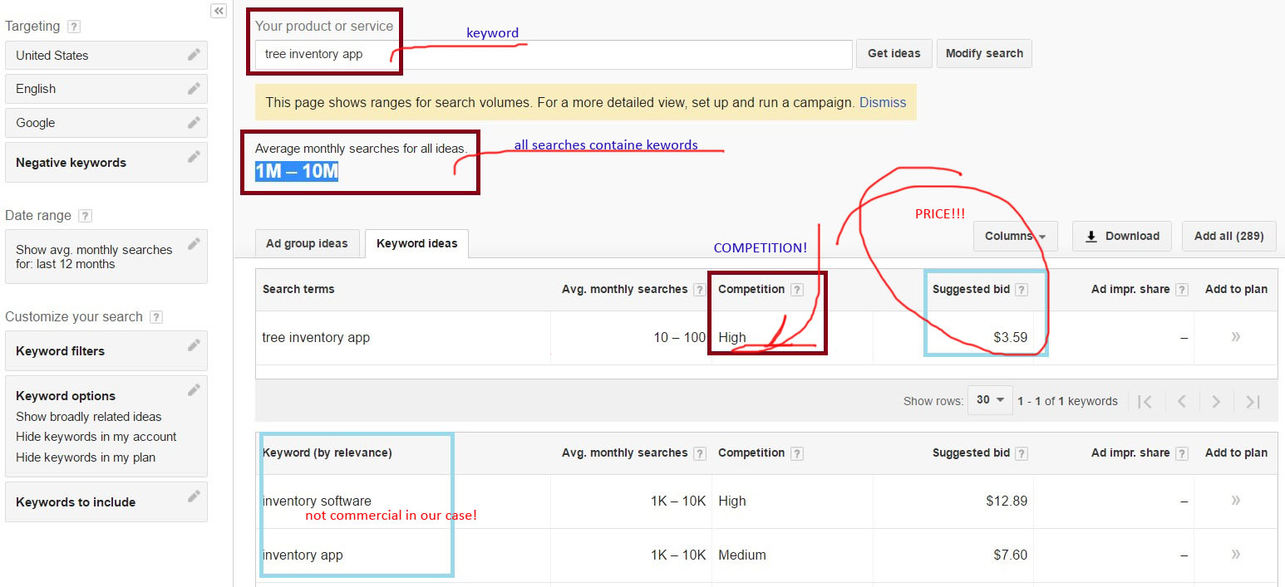

*Figure 1.* *Ranges for search volumes for keyword "tree inventory app"*

On the screenshot in Figure 1, the field "Average monthly searches for all ides" indicates how many times the keyword "tree inventory app" was included in various combinations for Google Search Engine. This field also shows that it was around from 1 to 10 millions times. If we take into the account the statistical conversion of the impressions (number of people who see your PPC advertisment) into the visitors, and this is 10% of the all requests, and the visitors to possible customers, up to 2%, we get after computing about 2,000 times per site per month for all possible combinations of the keyword. Google gives statistics, see the Figure 1, that a specific word has visitors in the range of 10 to 100 per month. The presence of a rather high price (it is a hight price per click!) proves the existence of CTR (click-through rate - is the ratio of users who click on a specific link to the number of total users who can view a page, email, or advertisement, which calculates by Google Adwords), which means that the ratio of clickability to impressions is greater than zero, which proves that there is a demand for this type of product or service. And from our overview Google Play store choice of applications available is anadequate to the demand.

Only one advertisment were found on a special placment (most expensive, above organic search results) to explore.

Figure 2, TreePlotter application overview, shows some preview of mobile application.

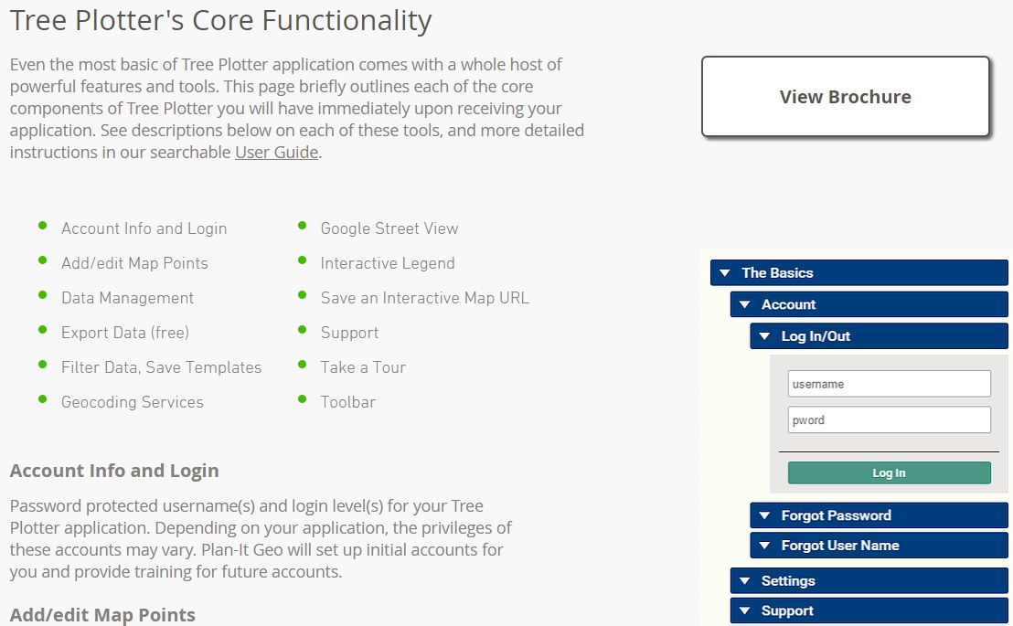

*Figure 2. TreePlotter application overview the only one page.*

* Name: Tree Plotter
* Rating: Not available
* Price: Extremely high (>1250 of basic configuration)
* Promotion: PPC

Pros and Cons are not avalable for exploring.

* **No distributing the tree inventory applications websites that were found by the results of Organic search**
* **No supporting active pages from Social Media were found (Facebook)**

1. Solution for the TreeLOG application

**5.a Overview of the solution draft**

**Functionality at the initial phase**

According to a project description, a virtual map and mobile application should include the functionalities listed in the below table. In order to increase usability we have decided to include more useful functions.

|  |  |  |
| --- | --- | --- |
| **Function** | **Action** | **Benefit (in compare with current way to process data)** |
| Track GPS location of the tree | Will mark the coordinates of the tree and save to the database | Will automatically save GPS coordinates of the tree instead of writing it in a regular spreadsheet. Will save time in more usable way. |
| Identifying type of the tree | Will use special algorithm build in the mobile application for comparing a photo of the tree leaf to the existing database of all North America trees | Will help to identify a particular type or subtype of a tree automatically instead of relying on a volunteer's knowledge . Will help to avoid mistakes during identifying. A lot of the trees are not identified at all. |
| Photo uploading capabilities | Will use phone's camera to make picture in the application interface with option to save in the database | Functionality was not implemented. Pictures of the trees were not taken. |
| Identify hazards | Will use preset data for usability and identifying a level of the hazard for future actions. | Currently, volunteers make notes in a spreadsheet. Will help to create a sequence of actions and preventive measures |
| Storing all tree related data in database | All data will be saved in a database | Currently all data saved in spreadsheets and paper documents |
| Login options (regular, facebook, google+) | Will allow to use the application | No application in use |
| Administrator of the application | Will allow to customize the application forms | No application in use |

**Functionality at the final phase**

|  |  |  |
| --- | --- | --- |
| **Function** | **Implemented** | **Description** |
| Track GPS location of the tree | Done | Works in different locations |
| Identifying type of the tree | Not implemented | Was not implemented because of limited time and resources. This functionality left on the TODO list. |
| Photo uploading capabilities | Done | Working properly on uploading one photo as well as on uploading many photos at once. Also the program has making photo capabilities. |
| Identify hazards | Done | TreeLOG uses preset data for users convenience and making notes |
| Storing all tree related data in database | Done | The application uses Firebase (real-time cloud database) technology for storing data |
| Login options (regular, facebook, google+) | Done (regular, google) | Facebook authentication not implemented yet. This functionality left on the TODO list. |
| Administrator of the application | Not implemented | Not resolved question about hosting with the client |

5.b TODO Screens of our application with description

5.c. TODO Transition diagram

5.d. TODO: tutorial/help/ for the learners

1. TODO: Describe the feedback that you got on your initial working prototype: how many participants you had and their demographic characteristics (but don’t include personally identifying information). Summarize the problems you discovered and describe what you changed in your final prototype to address those problems. Feedback

jhgkjgkjgh

1. Open issues (TODO: draft)

* Validation for tree duplicates
* Location accuracy

1. Future of the project (draft)

**Current phase**

At the moment, the project must be completed, tested and sent to the customer. All bugs should be fixed. All functionality should be implemented according to the specification.

**Short term perspectives**

TreeLOG application can be used by any organization or person who needs to make tree inventory, such as small town municipalities, departments of parks and recreation, landscape companies and designers, golf clubs, medical centers and rehabilitations, large estates to maintain landscape etc.

TreeLOG application can be improved in several directions, separately or all functionality together listed below:

* User Interface improvement, such as integration with existed database of species in Northern America and step by step tree recognition by using this database.
* User Interface improvement by adding a tutorial how to use the application and glossary.
* Integration with binominal nomenclature (formal system of naming species of living things by giving each a name composed of two parts, both of which use Latin grammatical forms)
* Classification of all types damages (biotic or abiotic) and creation different levels of awareness for treatment suggestions or immediate removal
* Export data to \*.cvs file for client's needs analysis
* Build iOS version of TreeLOG application

**Long term perspectives**

In a long term perspective the TreeLOG can be customized depending on client's needs. Let's assume that we have Department of NYC Parks and Recreations as a client. There are several regulations which could be integrated into the application, for example:

* Tree Planting Standards [4]. This document includes Design requirements, Plan Pest Control requirements, Materials, Planting specification, Seasonal Maintenance. By integrating all the standards with different levels of awareness we will get full inventory with prioritized suggestions for trees maintenance.
* Approximated costs or a particular contractor's cost of the different types of maintains could be added into the application. Integration with obtained inventory with prioritized suggestions will improve budget management.
* Integration with existed client's database.

Another way to improve the application is to obtain more comprehensive User Interface using Image processing algorithms not only for species recognition but shape, sizes, distance in between trees, etc.

**Promotion**

**Online promotion**

* Distribution of the application in AppStore for free in Basic configuration
* Distribution of the application in Google Play in Basic configuration
* Supporting website
* Supporting Social Media page on Facebook
* PPC Adwords advertisement campaigns

**Offline promotion**

* Creating a marketing plan of application presentation for 12 months to attend all events in the promoting area related to environmental issues, communities and municipalities budget discussions, inventory software development expos etc.

1. Achievement in CfC 2017 (draft)

After the presentation of the idea of the project in the first round, our team became one of the thirteen finalists among thirty participants.

1. References (draft)

1. https://en.wikipedia.org/wiki/Tree\_inventory

2. https://en.wikipedia.org/wiki/Urban\_forestry

3. https://en.wikipedia.org/wiki/Click-through\_rate

4. https://www.nycgovparks.org/pagefiles/53/Tree-Planting-Standards.pdf